Charley Kirk
Dr. Rhodes
Data Mining
1 December 2024
Recent Graduates Draft 12/01/24
Project Description
This project is about analyzing a dataset that contains information about recent graduates, including their major, their employment, their gender, and their earnings. Each observation in the dataset is of a different major. This dataset was last updated 7 years ago. The data was used in a piece by FiveThirtyEight on “the earnings of college majors.” The csv I pulled from is for a table with 21 attributes so I picked 15 of them to use for this project. I have given variable descriptions for these 15 attributes in the Data Sources section. For this project I think it was suggested that we pick something from our major, but my major is Data Science so I just tried to pick a subject that was somewhat interesting to me. This data is interesting to me personally because I have been job searching as a graduate for some time now without much success. From this dataset I was hoping to find out whether graduates who have jobs that require college degrees are financially better off than graduates who have jobs that do not require a college degree. Ideally the results would help recent graduates or people who are graduating soon know what to expect financially post-graduation. They would also potentially help people who have not gone to college by informing their decision on whether or not to pursue a college degree.
Data Sources
I found this dataset on data.world after clicking on their “education” data topic; from the list of datasets I picked one called “College Majors” and from a group of csvs I picked out the one called “recent-grads.csv.”
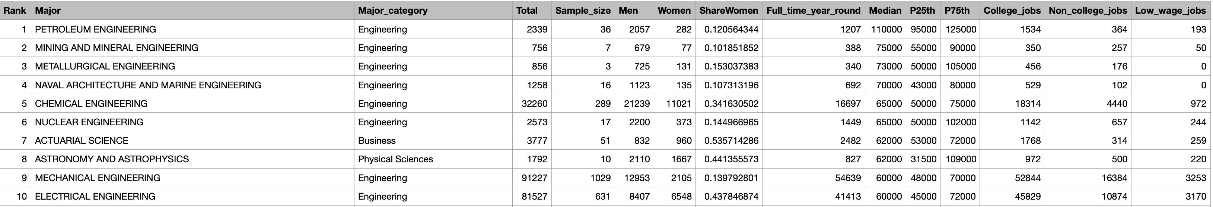
I originally used the glimpse function in RStudio to create snippets of the table to show on this document. But because of large value lengths some attributes like Major would display less than five values. So I took screenshots of the data in csv format. Here is the head of the data:

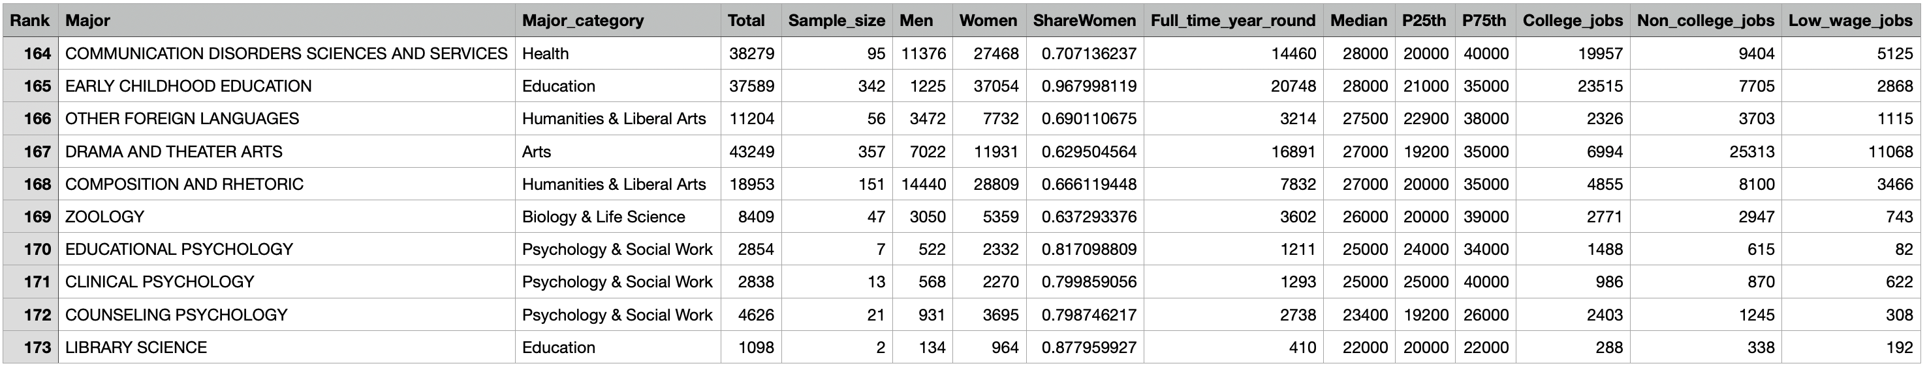
Here is the tail of the data:

Name | Type | Range | Description
Rank | Ordinal, discrete. |  | An assigned ranking based on the median earnings of graduates who work full-time and year-round.
Major | Nominal, categorical |  | The name of the major, e.g. Petroleum Engineering.
Major_category | Nominal, categorical |  | Gives a broader field the major falls into, e.g. “Engineering” instead of “Petroleum Engineering.”
Total | Ratio, discrete | Non-negative. | The number of graduates with the major.
Sample_size | Ratio, discrete | Non-negative. | The number of graduates who work full-time and year-round used to compute Median, P25th and P75th.
Men | Ratio, discrete | Non-negative. | The number of men who graduated with the major.
Women | Ratio, discrete | Non-negative. | The number of women who graduated with the major.
ShareWomen | Ratio, continuous | 0 to 1. | The decimal proportion of graduates in the major who are women.
Full_time_year_round | Ratio, discrete | Non-negative. | The number of graduates in the major who work at least 35 hours a week and at least 50 weeks a year based on “WKW” and “WKHP.”
Median | Ratio, discrete | Non-negative. | The median annual income of graduates in the major who work full-time and year-round.
P25th | Ratio | Non-negative. | Same as above but it’s the 25th percentile not the 50th percentile.
P75th | Ratio | Non-negative. | Same again but it’s the 75th percentile.
College_jobs | Ratio | Non-negative. | The number of graduates in the major who have a job that requires a college degree.
Non_college_jobs | Ratio | Non-negative. | The number of graduates in the major who have a job that does not require a college degree.
Low_wage_jobs | Ratio | Non-negative. | The number of graduates in the major who have a “low-wage service job.”

URLs

Note: when you use the Census Bureau link for the page where the data was originally pulled a 404 message pops up. But below that message you should see a hyperlink for the American Community Survey (ACS) page which I believe is the survey that was used to collect the data. I also included a link for the College Majors dataset on data.world, and a github link for FiveThirtyEight that was provided on that data.world page.

https://data.world/fivethirtyeight/college-majors
https://github.com/fivethirtyeight/data
http://www.census.gov/acs/www/data_documentation/pums_data/
Data Preprocessing

The dataset I found was already relatively clean, but I did use RStudio to create different versions of the data. Here is a copy of the code I used:

```{r setup, include=FALSE}
knitr::opts_chunk$set(echo = TRUE)
```

```{r}
library(tidyverse)
library(GGally)
library(classInt)
library(Hmisc)
library(funModeling)
```

```{r}
recent_grads <- read_csv("~/Dropbox/Charley/Juniata/Data Science Masters/Data Mining/recent-grads.csv")
```

Here I create the recsub dataframe with just 15 of the columns from recent_grads:
```{r}
recsub<-recent_grads%>%
select(Rank, Major, Major_category, Total, Sample_size, Men, Women, ShareWomen, Full_time_year_round, Median, P25th, P75th, College_jobs, Non_college_jobs, Low_wage_jobs)
```

```{r}
recsub_binned<-recsub%>%
mutate(College_jobs_binned = cut(College_jobs, breaks=3),
Non_college_jobs_binned = cut(Non_college_jobs, breaks=3),
Median_binned = cut(Median, breaks=3),
Total_binned = cut(Total, breaks=3),
Sample_size_binned = cut(Sample_size, breaks=3),
Men_binned = cut(Men, breaks=3),
Women_binned = cut(Women, breaks=3),
ShareWomen_binned = cut(ShareWomen, breaks=3),
Full_time_year_round_binned = cut(Full_time_year_round, breaks=3),
P25th_binned = cut(P25th, breaks=3),
P75th_binned = cut(P75th, breaks=3),
Low_wage_jobs_binned = cut(Low_wage_jobs, breaks=3))
```

I created recsub_binarized to have mostly binary attributes so I could use the Python code for generating hierarchical clusters that we had for one of our assignments. To convert columns to binary attributes I first created binned versions of the columns using cut, then used pivot_wider() to turn those binned values into columns with values provided by the original unbinned columns. Then I replaced the resulting NA values with 0’s and used the mutate_if() function to turn the nonzero numbers into 1’s.

```{r}
set.seed(74)
recsub_binarized<-recsub%>%
select(Major, Major_category, College_jobs, Non_college_jobs, Median, Total)%>%
sample_n(20)
recsub_binarized<-recsub_binarized%>%
mutate(College_jobs_binned = cut(College_jobs, breaks=3),
Non_college_jobs_binned = cut(Non_college_jobs, breaks=3),
Median_binned = cut(Median, breaks=3),
Total_binned = cut(Total, breaks=3))%>%
pivot_wider(names_from = College_jobs_binned, values_from = College_jobs, names_glue = "{College_jobs_binned}_{.value}")%>%
pivot_wider(names_from = Non_college_jobs_binned, values_from = Non_college_jobs, names_glue = "{Non_college_jobs_binned}_{.value}")%>%
pivot_wider(names_from = Median_binned, values_from = Median, names_glue = "{Median_binned}_{.value}")%>%
pivot_wider(names_from = Total_binned, values_from = Total, names_glue = "{Total_binned}_{.value}")
recsub_binarized<-replace(recsub_binarized, is.na(recsub_binarized), 0)
recsub_binarized<-recsub_binarized%>%
mutate_if(is.numeric, ~1 * (. != 0))
```

```{r}
write_csv(recsub_binned, "~/Dropbox/Charley/Juniata/Data Science Masters/Data Mining/recsub_binned.csv")
```

Some of the data mining results I included in this document make use of recsub_binned2, which has binned versions of my numeric attributes. College_jobs_binned has 10 bins while all the other binned attributes have 3 bins.
```{r}
recsub_binned2<-recsub%>%
mutate(College_jobs_binned = cut(College_jobs, breaks=10),
Non_college_jobs_binned = cut(Non_college_jobs, breaks=3),
Median_binned = cut(Median, breaks=3),
Total_binned = cut(Total, breaks=3),
Sample_size_binned = cut(Sample_size, breaks=3),
Men_binned = cut(Men, breaks=3),
Women_binned = cut(Women, breaks=3),
ShareWomen_binned = cut(ShareWomen, breaks=3),
Full_time_year_round_binned = cut(Full_time_year_round, breaks=3),
P25th_binned = cut(P25th, breaks=3),
P75th_binned = cut(P75th, breaks=3),
Low_wage_jobs_binned = cut(Low_wage_jobs, breaks=3))
```

I realized at one point that my data had a class imbalance problem; there were some values of College_jobs_binned that were pretty rare. One idea I had to fix this was to use oversampling. I created the recsub_increased dataframe to have duplicates of observations that had less common values of College_jobs_binned. This recsub_increased dataframe seemed to have great performance on many of the data mining algorithms. My mistake, which I didn’t realize until pretty late into the project, was that by oversampling before splitting the data into training and test datasets in Weka, I was making it so that some observations were being used both to train the data and to test the data. This led to misleadingly good classification performance. After realizing the flaw with splitting recsub_increased, I tried splitting the nonoversampled data into training and test dataframes then oversampling the training data. Unfortunately I failed to preserve the code used to create recsub_increased, but the next few R chunks show how I created the oversampled training dataframe recsub_increased_training and the test dataframe recsub_test, and I believe recsub_increased was created in a similar manner to recsub_increased_training.

```{r}
set.seed(56)
recsub_training<-recsub_binned2%>%
sample_n(size=114)
recsub_test<-setdiff(recsub_binned2, recsub_training)
```

```{r}
recsub_small_vals<-recsub_training%>%
filter(College_jobs<=30328.6)
recsub_large_vals<-recsub_training%>%
filter(College_jobs>30328.6)
```

```{r}
recsub_increased_training <- cbind(recsub_large_vals, rep(row.names(recsub_large_vals), each = 9))%>%
select(-"rep(row.names(recsub_large_vals), each = 9)")
recsub_increased_training<-union_all(recsub_small_vals, recsub_increased_training)
```
Weka allows you to supply your own test set so I thought using both recsub_increased_training and recsub_test might fix my problem. Unfortunately the classification performance was pretty bad. I suspect the fundamental problem was that because some bins in the nonoversampled data only had 1 value in them, having that 1 value go into the training data made the test data bad, while having that 1 value go into the test data meant the training data would be bad. I tried to improve my results by oversampling the already oversampled data again to get even more balanced classes, but I don’t think it worked very well. I then tried using equal_freq() to create equal frequency bins (same number in each bin) instead of using cut() to create equal width bins (same interval lengths).

```{r}
recsub_binned3<-recsub%>%
mutate(College_jobs_binned = equal_freq(College_jobs, 10),
Non_college_jobs_binned = equal_freq(Non_college_jobs, 10),
Median_binned = equal_freq(Median, 10),
Total_binned = equal_freq(Total, 10),
Sample_size_binned = equal_freq(Sample_size, 10),
Men_binned = equal_freq(Men, 10),
Women_binned = equal_freq(Women, 10),
ShareWomen_binned = equal_freq(ShareWomen, 10),
Full_time_year_round_binned = equal_freq(Full_time_year_round, 10),
P25th_binned = equal_freq(P25th, 10),
P75th_binned = equal_freq(P75th, 10),
Low_wage_jobs_binned = equal_freq(Low_wage_jobs, 10))
```

The results might have been better but I tried figuring out another way to improve things. Taking into account the distribution of College_jobs, I created recsub_binned4 by making the first 9 bins of College_jobs_binned equal width and giving the last bin a larger interval. The results still weren’t awesome but they seemed to be an improvement over the results obtained with recsub_binned3. recsub_binned4 is the dataset I wound up using for most of the data mining results I give in this paper.
```{r}
recsub_binned4<-recsub%>%
mutate(College_jobs_binned=cut(College_jobs, breaks=c(0, 1667, 3333, 5000, 6667, 8333, 10000, 11667, 13333, 15000, 151643)),
Non_college_jobs_binned = cut(Non_college_jobs, breaks=10),
Median_binned = cut(Median, breaks=10),
Total_binned = cut(Total, breaks=10),
Sample_size_binned = cut(Sample_size, breaks=10),
Men_binned = cut(Men, breaks=10),
Women_binned = cut(Women, breaks=10),
ShareWomen_binned = cut(ShareWomen, breaks=10),
Full_time_year_round_binned = cut(Full_time_year_round, breaks=10),
P25th_binned = cut(P25th, breaks=10),
P75th_binned = cut(P75th, breaks=10),
Low_wage_jobs_binned = cut(Low_wage_jobs, breaks=10))%>%
filter(is.na(College_jobs_binned)==FALSE)
```

```{r}
recsub_tail<-
recsub%>%
tail(10)
```

```{r}
write_csv(recsub_increased_training, "~/Dropbox/Charley/Juniata/Data Science Masters/Data Mining/recsub_increased_training.csv")
```

```{r}
write_csv(recsub_binned3, "~/Dropbox/Charley/Juniata/Data Science Masters/Data Mining/recsub_binned3.csv")
```

```{r}
write_csv(recsub_binned4, "~/Dropbox/Charley/Juniata/Data Science Masters/Data Mining/recsub_binned4.csv")
```

```{r}
write_csv(recsub_test, "~/Dropbox/Charley/Juniata/Data Science Masters/Data Mining/recsub_test.csv")
```

```{r}
write_csv(recsub_binned2, "~/Dropbox/Charley/Juniata/Data Science Masters/Data Mining/recsub_binned2.csv")
```

```{r}
write_csv(recsub_tail, "~/Dropbox/Charley/Juniata/Data Science Masters/Data Mining/recsub_tail.csv")
```
Data Exploration/Visualization

The following two graphs were made using RStudio.
recent_grads%>%
pivot_longer(c(Men, Women), names_to = "Gender", values_to = "G_Total")%>%
ggplot()+
geom_col(aes(Major_category, G_Total, fill=Gender), position="dodge")+
coord_flip()
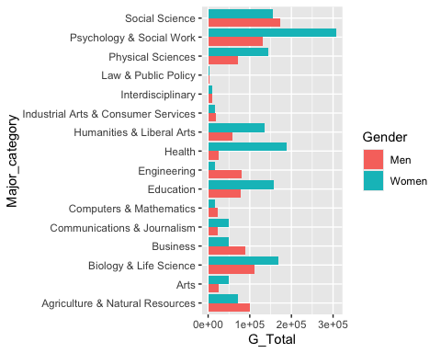
This is a side-by-side bar chart. The 16 major categories are shown on one axis and the other axis shows the number of graduates in that major category with the bars broken up by gender. Blue bars show the number of women in the major category and red bars show the number of men in the major category. From this graph we can observe that Engineering is much more popular with men than women, while Education is more popular with women than men. The Law and Public Policy category is pretty unpopular in general while Social Science seems pretty popular for both men and women.
recent_grads%>%
filter(Median>=60000)%>%
mutate(Major=fct_reorder(Major, Median))%>%
ggplot()+
geom_col(aes(Major, Total))+
coord_flip()
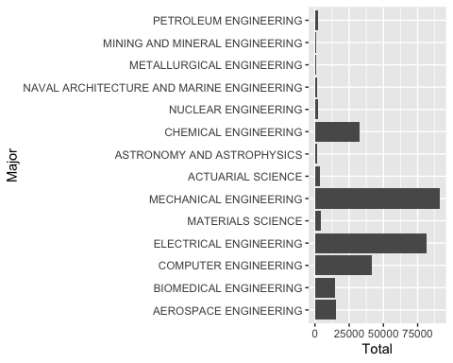
This graph was inspired by a table in the FiveThirtyEight piece that made use of the same data. Although I did not include Median in this graph explicitly, I did order the levels of Major in decreasing order of Median so that the majors with the highest median earnings appeared at the top and the majors with the lowest median earnings appeared at the bottom. That said the order is still slightly arbitrary because some majors have the same value for Median; for example Nuclear Engineering and Chemical Engineering have the same value for Median and so Chemical Engineering could be written before Nuclear Engineering and vice versa. The graph shows that even though majors like Petroleum Engineering, Mining and Mineral Engineering and Metallurgical Engineering all have high median earnings, there are majors with lower median earnings that are vastly more popular like Mechanical Engineering and Electrical Engineering.
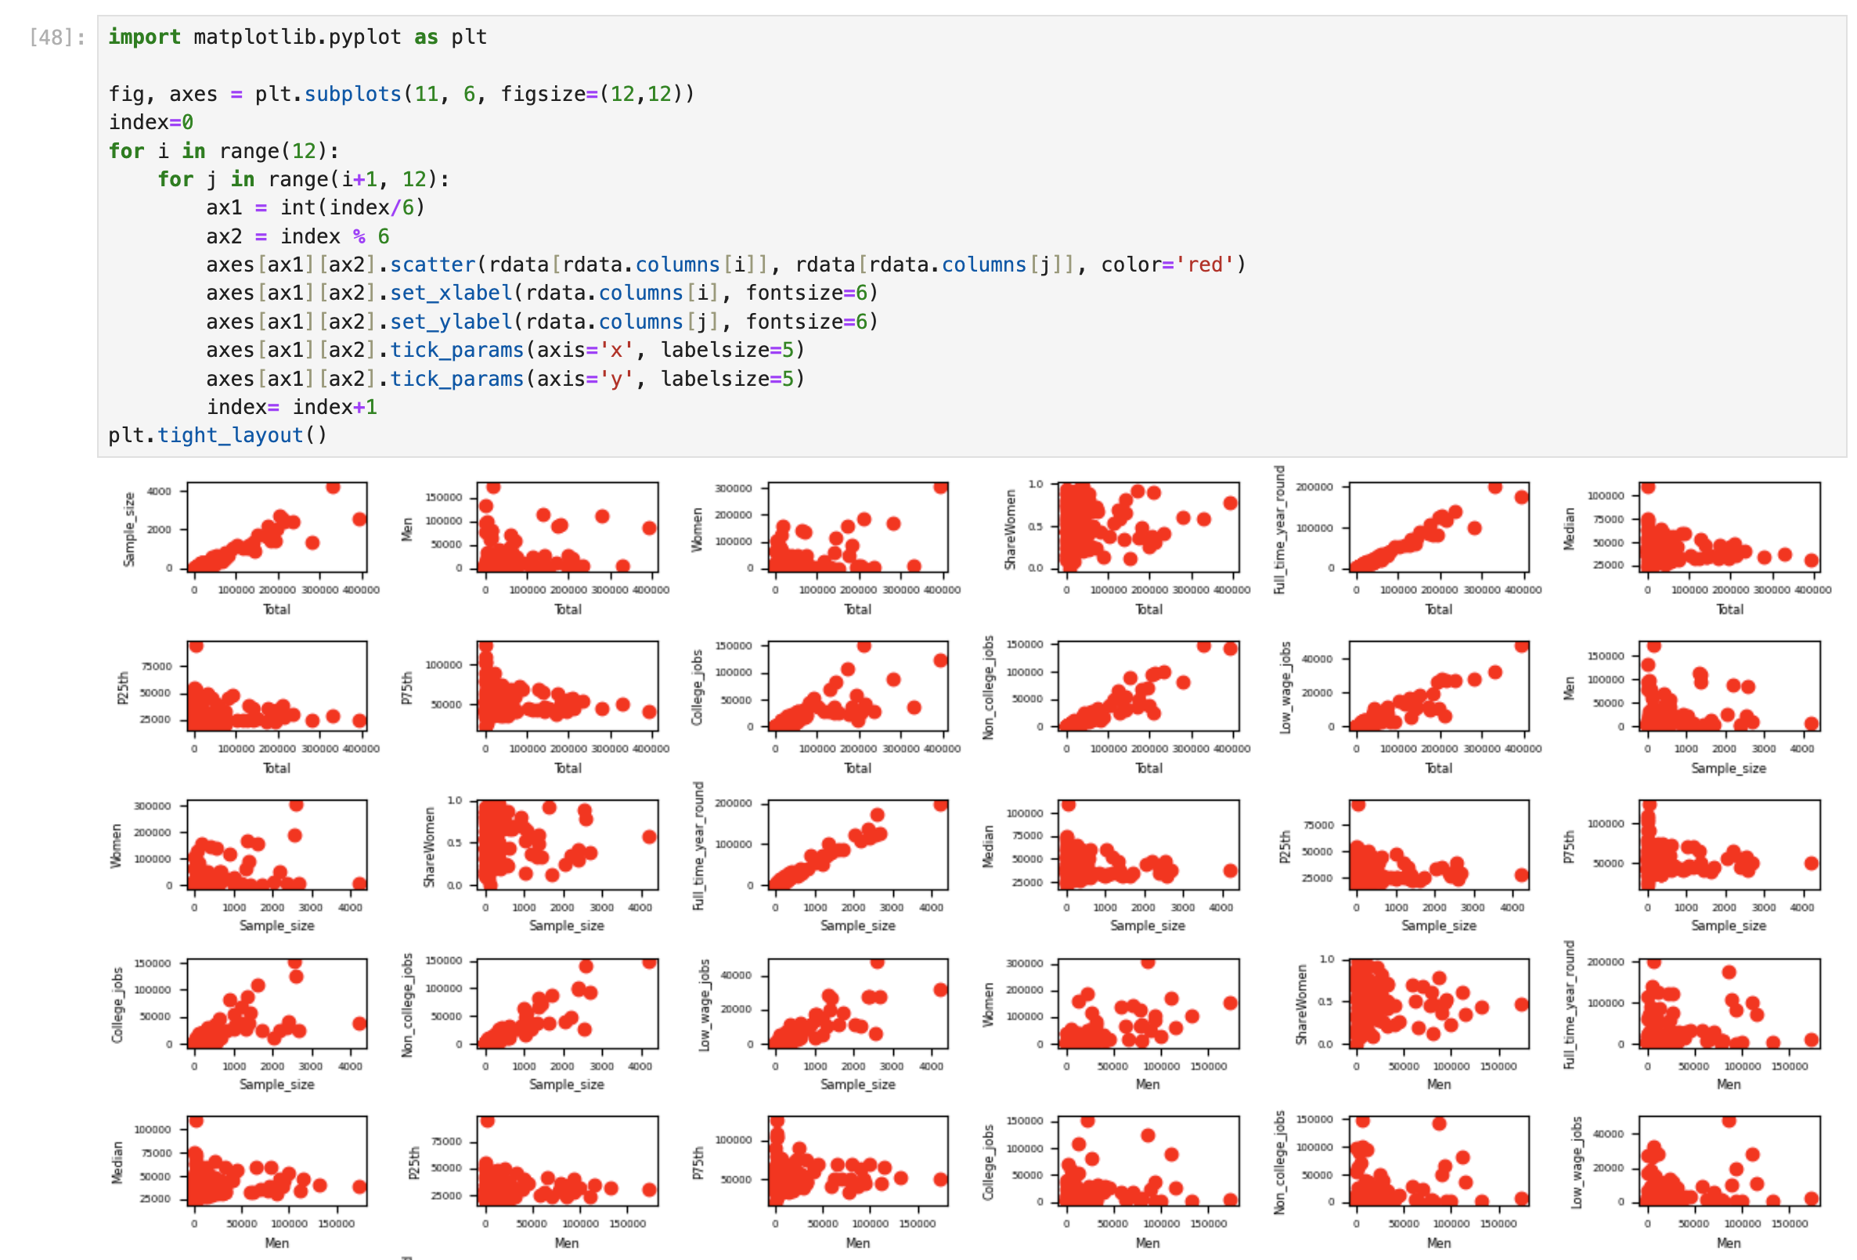
The following scatterplot matrix was made in Python.

The plot in the bottom right corner does suggest a strong positive correlation between the number of Non_college_jobs and the number of Low_wage_jobs, which may support the hypothesis that graduates who have jobs that require college degrees are financially better off than graduates who have jobs that do not require a college degree. On the other hand the plot of College_jobs and Median 2 spaces above does not show an obvious correlation.
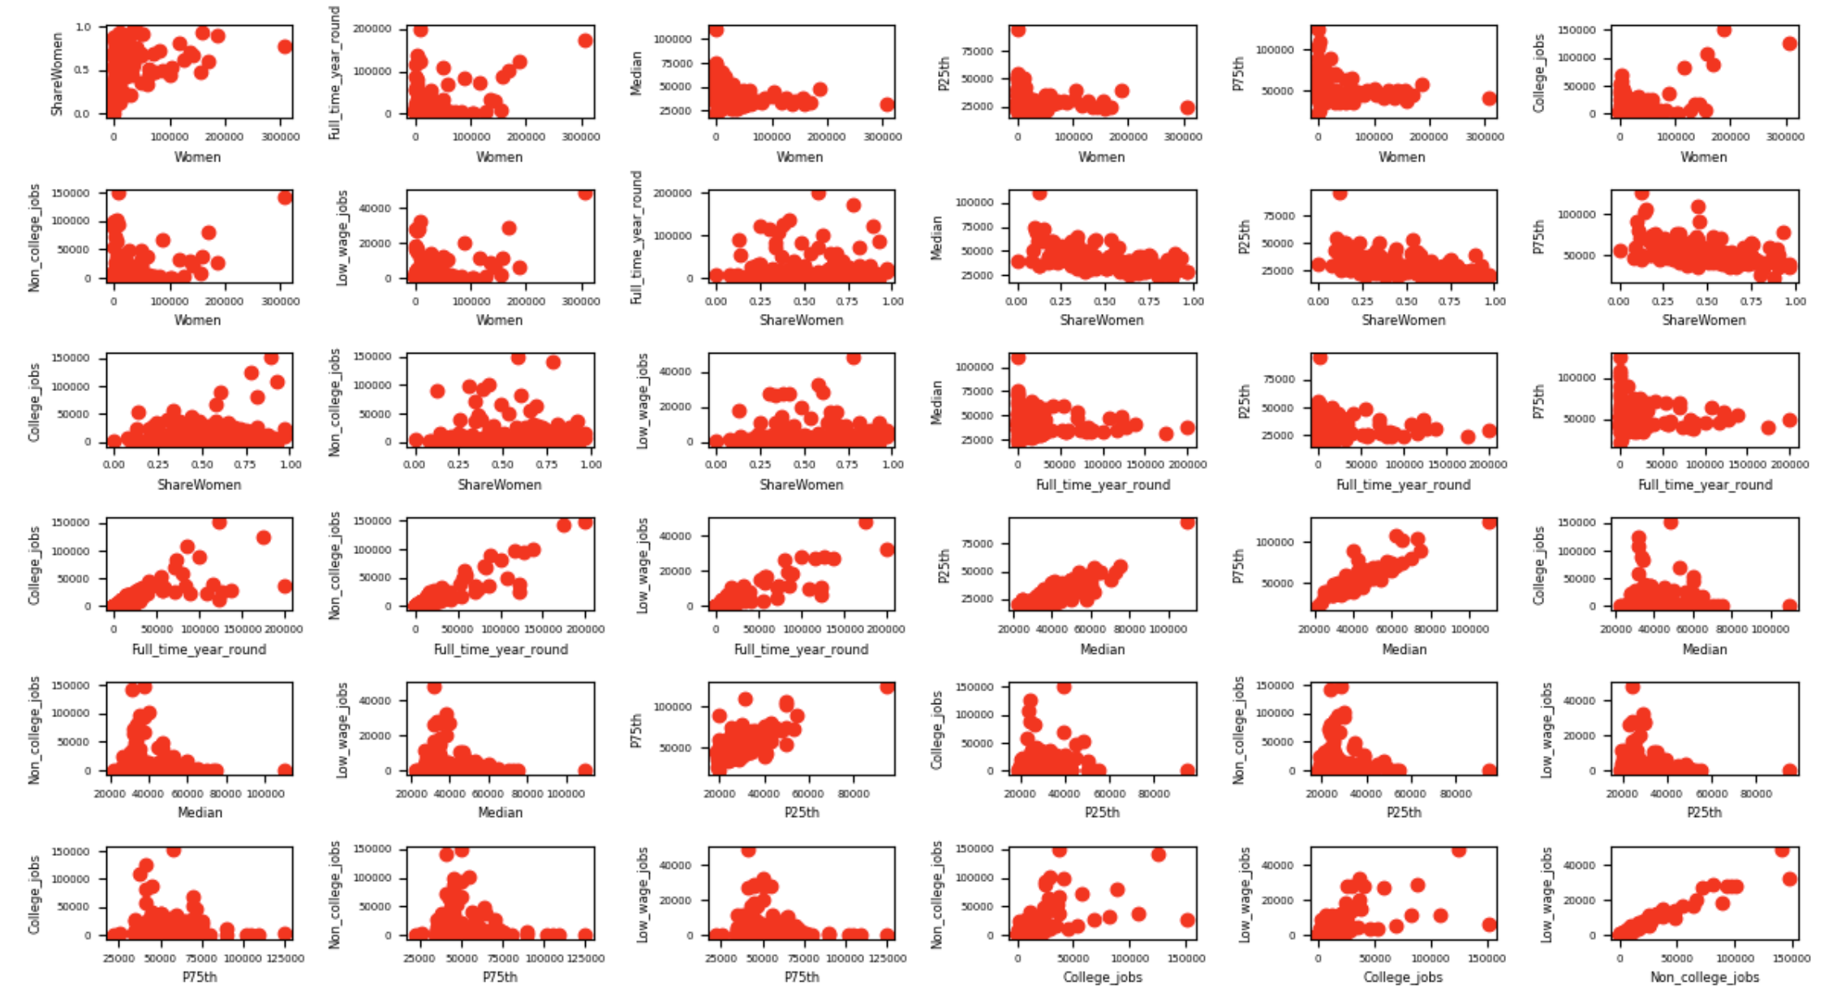
Early on I created the miningset dataframe to use with the Apriori algorithm in Weka since the algorithm didn’t accept quantitative variables. But I’m no longer using it for my data mining results. The reason I have it here is because I also happened to use it to create some exploratory graphs.
miningset<-recsub%>%
mutate(col_rate = (College_jobs/Total), col_bin=cut(col_rate, breaks=10), median_bin=cut(Median, breaks=10), low_rate=(Low_wage_jobs/Total), low_bin=cut(low_rate, breaks=10))%>%
select(Major_category, col_bin, median_bin, low_bin)
write.csv(miningset,"~/Dropbox/Charley/Juniata/Data Science Masters/Data Mining/miningset.csv")

miningset%>%
ggplot()+
geom_bar(aes(median_bin))+
coord_flip()
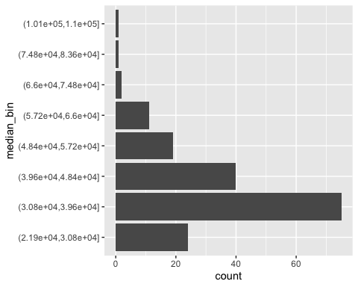
The graph of median_bin above is right-skewed which could be reflective of income inequality. It might look a bit similar to the graph of low_bin below.
miningset%>%
ggplot()+
geom_bar(aes(low_bin))+
coord_flip()
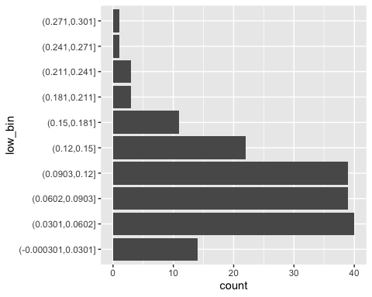
miningset%>%
ggplot()+
geom_bar(aes(col_bin))+
coord_flip()
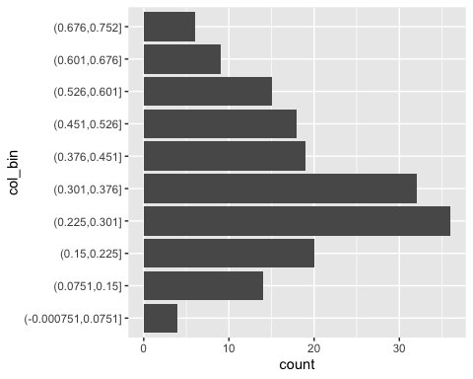
col_bin seems to have a more symmetric distribution, but it’s tricky to say whether that’s a good thing or not without finding a pattern between College_jobs and the income variables.
Data Mining
The first couple algorithms are done with Python and the rest are done using Weka. Most of the Weka results shown use training and test splits with some exceptions. I removed Rank and Major in Weka’s preprocessing stage in most if not all the Weka attempts shown.
Single Link Clustering
Below is the code I used to read my recsub_binarized data into a Python notebook.

import pandas as pd

recsub = pd.read_csv('/Users/Charley/Dropbox/Charley/Juniata/Data Science Masters/Data Mining/recsub_binarized.csv',header='infer')
data = recsub.drop('Major',axis=1)
data = data.drop (‘Major_category',axis=1)

And here is where I generated my single link dendrogram.

from scipy.cluster import hierarchy
import matplotlib.pyplot as plt
%matplotlib inline

names = recsub['Major']
Y = recsub['Major_category']
X=data
#X = data.drop(['Name','Class'],axis=1)
Z = hierarchy.linkage(X.values, 'single')
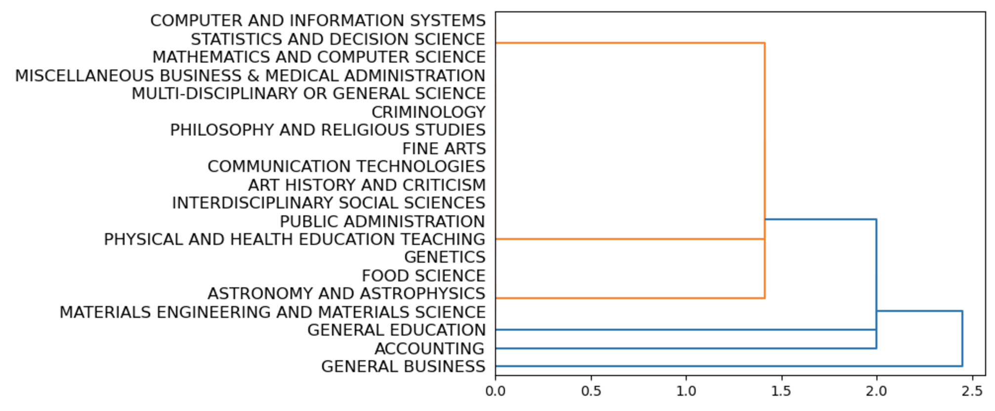
dn = hierarchy.dendrogram(Z,labels=names.tolist(),orientation=‘right')
As you might have noticed the code is just a slightly modified version of the code we used in class. This dendrogram and the complete link dendrogram both show values of Major_category on the left axis. I didn’t find either dendrogram useful to my goal, so I guess these dendrograms ended up being almost like a form of exploratory data analysis. Though I had these results for single link and complete link clustering for a long time I actually considered not including them for a long time since they were technically not required.
Complete Link Clustering
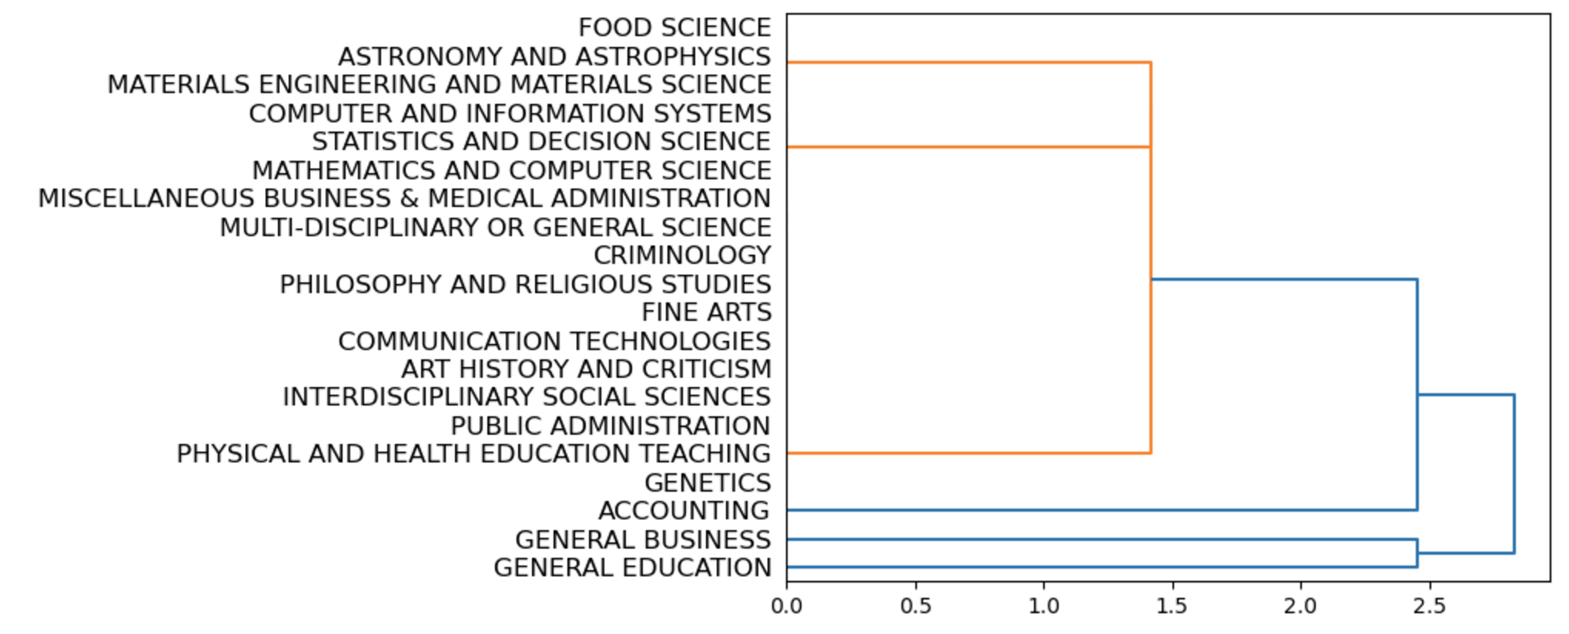
Here is where I generated a complete link dendrogram.

Z = hierarchy.linkage(X.values, 'complete')
dn = hierarchy.dendrogram(Z,labels=names.tolist(),orientation=‘right')

SimpleKMeans
These results are for the Weka SimpleKMeans algorithm on the recsub_binned4 dataset. Rank, Major, Major_category, College_jobs and all binned attributes besides College_jobs_binned were removed in preprocessing. I had numClusters set to 10 and “classes to clusters evaluation” selected under cluster mode with College_jobs_binned selected as the class variable. I thought these settings would make the classes to clusters matrix in the result buffer equivalent to a normal confusion matrix, something I had been able to achieve with recsub_increased, but there were some clusters that didn’t get assigned a value of College_jobs_binned for some reason. It might be related to those two values, or bins, being the rarest in College_jobs_binned in recsub_binned4. I didn’t figure out a way to use test data with classes to clusters evaluation selected so the evaluation is done on training data.
Class attribute: College_jobs_binned
Classes to Clusters:

0 1 2 3 4 5 6 7 8 9 <-- assigned to cluster
9 3 7 7 6 2 5 1 0 2 | (0,1.67e+03]
3 9 2 2 1 3 0 10 6 7 | (1.5e+04,1.52e+05]
2 3 11 8 3 1 0 0 0 4 | (1.67e+03,3.33e+03]
1 0 2 1 0 0 0 2 1 0 | (6.67e+03,8.33e+03]
0 2 2 5 4 0 0 0 1 1 | (5e+03,6.67e+03]
2 4 2 4 1 1 0 2 0 1 | (3.33e+03,5e+03]
1 3 0 1 0 0 0 0 0 1 | (1e+04,1.17e+04]
1 1 0 0 0 0 0 1 0 0 | (1.33e+04,1.5e+04]
0 5 0 0 0 0 0 0 0 0 | (8.33e+03,1e+04]
0 1 0 1 0 0 0 0 0 0 | (1.17e+04,1.33e+04]

Cluster 0 <-- (0,1.67e+03]
Cluster 1 <-- (8.33e+03,1e+04]
Cluster 2 <-- (1.67e+03,3.33e+03]
Cluster 3 <-- (3.33e+03,5e+03]
Cluster 4 <-- (5e+03,6.67e+03]
Cluster 5 <-- No class
Cluster 6 <-- No class
Cluster 7 <-- (1.5e+04,1.52e+05]
Cluster 8 <-- (6.67e+03,8.33e+03]
Cluster 9 <-- (1e+04,1.17e+04]

Incorrectly clustered instances : 127.0 73.8372 %
IBk
This result was made using the recsub_binned4 dataset with KNN set to 1, with Rank, Major, College_jobs and all binned attributes besides College_jobs_binned removed in preprocessing, and with College_jobs_binned as the response variable. I also used the percentage split option under test options so 66% of the data was used for training and the rest for testing. KNN set to 1 means k=1 in the context of K Nearest Neighbors. I did try some higher values of k but they seemed to lead to more classification errors.
=== Summary ===

Correctly Classified Instances 22 37.931 %
Incorrectly Classified Instances 36 62.069 %
Kappa statistic 0.2601
Mean absolute error 0.1286
Root mean squared error 0.3387
Relative absolute error 77.1772 %
Root relative squared error 116.9065 %
Total Number of Instances 58

=== Confusion Matrix ===

a b c d e f g h i j <-- classified as
4 2 4 0 0 2 0 1 0 0 | a = (0,1.67e+03]
0 10 0 0 0 1 3 0 1 0 | b = (1.5e+04,1.52e+05]
3 1 3 1 1 0 0 0 0 0 | c = (1.67e+03,3.33e+03]
0 2 1 0 0 1 0 0 0 0 | d = (6.67e+03,8.33e+03]
2 0 2 0 2 1 1 0 0 0 | e = (5e+03,6.67e+03]
1 0 2 0 0 1 0 0 0 0 | f = (3.33e+03,5e+03]
0 0 0 0 0 0 2 0 0 0 | g = (1e+04,1.17e+04]
0 0 0 0 0 1 0 0 0 0 | h = (1.33e+04,1.5e+04]
0 0 0 0 0 2 0 0 0 0 | i = (8.33e+03,1e+04]
0 0 0 0 0 0 0 0 0 0 | j = (1.17e+04,1.33e+04]
JRIP
I think it was with this classifier that I first recognized the need to address class imbalance in my data. Lower values of College_jobs were much more common than higher values of College_jobs, which also meant that the first couple bins in College_jobs_binned were more common than the others. This meant that on test splits the number of correctly classified instances was misleadingly high because most instances were being assigned to the first bin. I noticed this by looking at the confusion matrices. So that’s when I had the idea to create the recsub_increased dataset with oversampling. I talk about that more in the Data Preprocessing section. Anyway this result was made using the recsub_increased dataset with Rank, Major, College_jobs and all binned attributes besides College_jobs_binned removed in preprocessing, and with College_jobs_binned as the response variable. I also used the percentage split option under test options so 66% of the data was used for training and the rest for testing. I explained in the Data Preprocessing section that I found out this dataset was giving problematic results but I wanted to show at least one result created using this dataset.
=== Summary ===

Correctly Classified Instances 103 95.3704 %
Incorrectly Classified Instances 5 4.6296 %
Kappa statistic 0.9409
Mean absolute error 0.0171
Root mean squared error 0.0964
Relative absolute error 9.941 %
Root relative squared error 32.3758 %
Total Number of Instances 108

=== Confusion Matrix ===

a b c d e f g h i <-- classified as
37 1 0 0 0 0 0 1 0 | a = (-152,1.52e+04]
3 3 0 0 0 0 0 0 0 | b = (1.52e+04,3.03e+04]
0 0 8 0 0 0 0 0 0 | c = (4.55e+04,6.07e+04]
0 0 0 6 0 0 0 0 0 | d = (6.07e+04,7.58e+04]
0 0 0 0 4 0 0 0 0 | e = (1.36e+05,1.52e+05]
0 0 0 0 0 26 0 0 0 | f = (3.03e+04,4.55e+04]
0 0 0 0 0 0 10 0 0 | g = (7.58e+04,9.1e+04]
0 0 0 0 0 0 0 4 0 | h = (1.06e+05,1.21e+05]
0 0 0 0 0 0 0 0 5 | i = (1.21e+05,1.36e+05]
As you can see the classification rate is pretty good at 95.3704%, and the confusion matrix has a great diagonal. Maybe in hindsight I should have realized this performance was too good to be true. I guess I at least learned a lesson in the end. This next result was done on recsub_binned4 with the same attributes omitted. Besides the summary and confusion matrix output I also put the classification rules generated by this attempt.
=== Summary ===

Correctly Classified Instances 32 55.1724 %
Incorrectly Classified Instances 26 44.8276 %
Kappa statistic 0.4301
Mean absolute error 0.1157
Root mean squared error 0.2601
Relative absolute error 69.3871 %
Root relative squared error 89.7662 %
Total Number of Instances 58

=== Confusion Matrix ===

a b c d e f g h i j <-- classified as
10 0 2 0 0 1 0 0 0 0 | a = (0,1.67e+03]
0 15 0 0 0 0 0 0 0 0 | b = (1.5e+04,1.52e+05]
2 1 6 0 0 0 0 0 0 0 | c = (1.67e+03,3.33e+03]
2 2 0 0 0 0 0 0 0 0 | d = (6.67e+03,8.33e+03]
5 0 1 0 0 2 0 0 0 0 | e = (5e+03,6.67e+03]
2 0 1 0 0 1 0 0 0 0 | f = (3.33e+03,5e+03]
2 0 0 0 0 0 0 0 0 0 | g = (1e+04,1.17e+04]
0 1 0 0 0 0 0 0 0 0 | h = (1.33e+04,1.5e+04]
1 1 0 0 0 0 0 0 0 0 | i = (8.33e+03,1e+04]
0 0 0 0 0 0 0 0 0 0 | j = (1.17e+04,1.33e+04]

JRIP rules:
===========

(Sample_size >= 375) and (Full_time_year_round <= 21816) => College_jobs_binned=(1.33e+04,1.5e+04] (3.0/0.0)
(Non_college_jobs >= 12037) and (Total <= 33599) => College_jobs_binned=(8.33e+03,1e+04] (2.0/0.0)
(Low_wage_jobs >= 6866) and (Non_college_jobs <= 23059) => College_jobs_binned=(8.33e+03,1e+04] (2.0/0.0)
(Major_category = Education) and (Total <= 20198) and (Total >= 14237) => College_jobs_binned=(1e+04,1.17e+04] (4.0/0.0)
(Full_time_year_round <= 10548) and (Sample_size >= 132) and (Median <= 35000) => College_jobs_binned=(3.33e+03,5e+03] (9.0/1.0)
(Total >= 3635) and (Total <= 10399) => College_jobs_binned=(1.67e+03,3.33e+03] (31.0/10.0)
(Total <= 10510) => College_jobs_binned=(0,1.67e+03] (35.0/1.0)
=> College_jobs_binned=(1.5e+04,1.52e+05] (86.0/43.0)
I don’t think I gleaned anything meaningful from these rules other than something regarding Full_time_year_round which I’ll get into later.
MultiLayerPerceptron
In addition to the summary data and the confusion matrix I provided a screenshot of the image of the neural network generated by Weka. This result was made using the recsub_binned4 dataset with Rank, Major, College_jobs and all binned attributes besides College_jobs_binned removed in preprocessing, and with College_jobs_binned as the response variable. For this result I set hiddenLayers to “2,2” for a neural network with 2 hidden layers that each had two nodes, and I set learningRate to 0.3.
=== Stratified cross-validation ===
=== Summary ===

Correctly Classified Instances 78 45.3488 %
Incorrectly Classified Instances 94 54.6512 %
Kappa statistic 0.3029
Mean absolute error 0.1266
Root mean squared error 0.2655
Relative absolute error 76.5192 %
Root relative squared error 92.5325 %
Total Number of Instances 172

=== Confusion Matrix ===

a b c d e f g h i j <-- classified as
27 1 13 0 1 0 0 0 0 0 | a = (0,1.67e+03]
0 36 3 0 3 0 1 0 0 0 | b = (1.5e+04,1.52e+05]
17 1 14 0 0 0 0 0 0 0 | c = (1.67e+03,3.33e+03]
0 1 4 0 2 0 0 0 0 0 | d = (6.67e+03,8.33e+03]
5 4 6 0 0 0 0 0 0 0 | e = (5e+03,6.67e+03]
4 0 10 0 1 1 1 0 0 0 | f = (3.33e+03,5e+03]
1 3 1 0 1 0 0 0 0 0 | g = (1e+04,1.17e+04]
0 3 0 0 0 0 0 0 0 0 | h = (1.33e+04,1.5e+04]
0 2 1 0 2 0 0 0 0 0 | i = (8.33e+03,1e+04]
0 2 0 0 0 0 0 0 0 0 | j = (1.17e+04,1.33e+04]

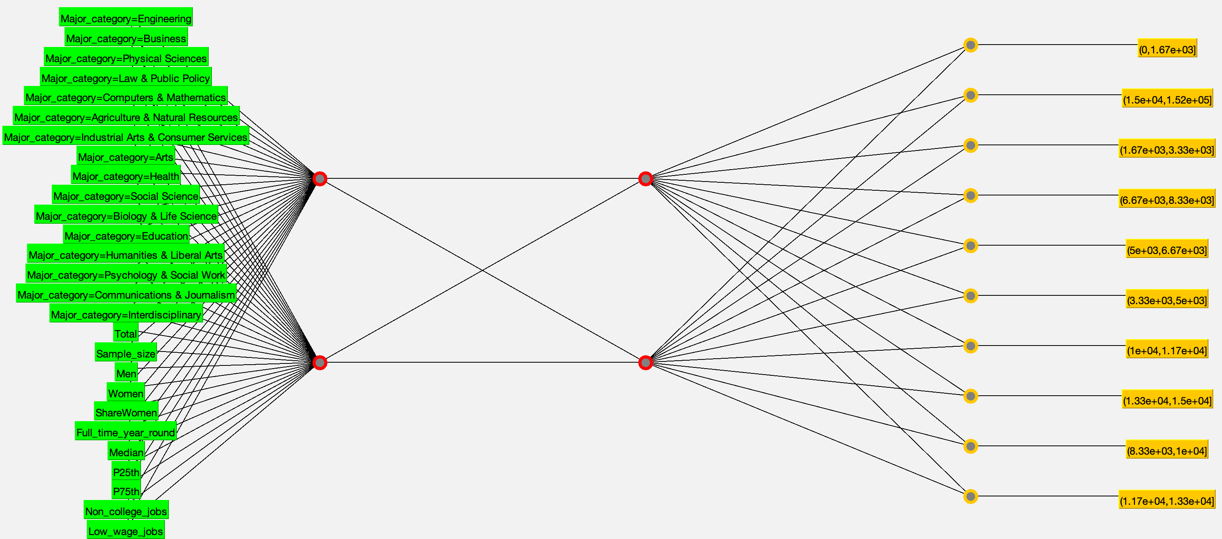
For this next result I used recsub_binned4 with the same attributes omitted, and I set hiddenLayers to 9 for a neural network with 1 hidden layer that had 9 nodes, and I set learningRate to 0.1.
=== Stratified cross-validation ===
=== Summary ===

Correctly Classified Instances 92 53.4884 %
Incorrectly Classified Instances 80 46.5116 %
Kappa statistic 0.4214
Mean absolute error 0.1184
Root mean squared error 0.2569
Relative absolute error 71.5543 %
Root relative squared error 89.5232 %
Total Number of Instances 172

=== Confusion Matrix ===

a b c d e f g h i j <-- classified as
29 0 7 0 3 2 1 0 0 0 | a = (0,1.67e+03]
0 39 0 0 1 1 1 0 1 0 | b = (1.5e+04,1.52e+05]
14 1 11 0 3 3 0 0 0 0 | c = (1.67e+03,3.33e+03]
1 1 2 0 0 3 0 0 0 0 | d = (6.67e+03,8.33e+03]
4 2 1 1 4 1 1 0 1 0 | e = (5e+03,6.67e+03]
5 0 5 1 2 4 0 0 0 0 | f = (3.33e+03,5e+03]
0 1 0 0 1 0 4 0 0 0 | g = (1e+04,1.17e+04]
0 3 0 0 0 0 0 0 0 0 | h = (1.33e+04,1.5e+04]
0 2 0 0 0 2 0 0 1 0 | i = (8.33e+03,1e+04]
0 2 0 0 0 0 0 0 0 0 | j = (1.17e+04,1.33e+04]

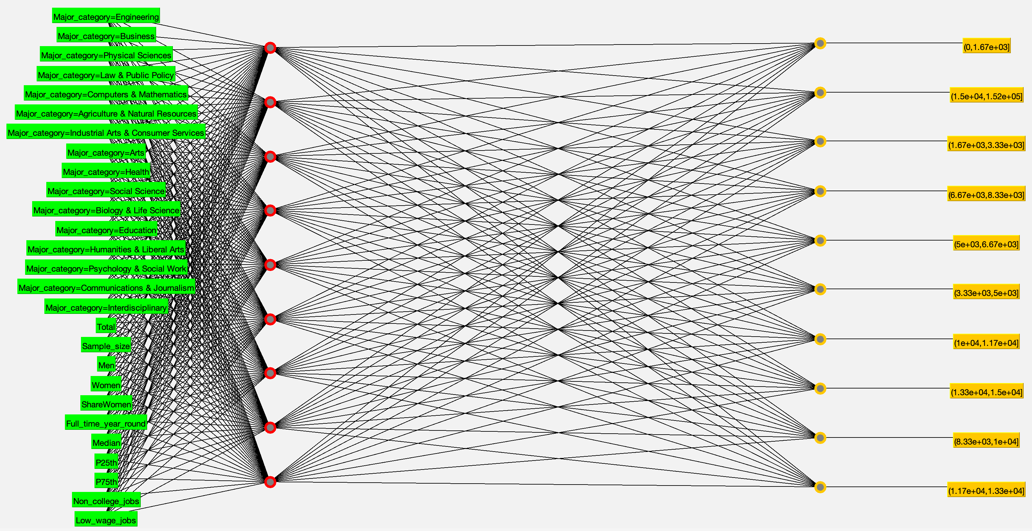
As you can see the classification rate improved. I think in general lower learning rates might be better for running this algorithm on my data. For most of my data mining results I used training and test splits but for these runs of MultilayerPerceptron I used 10 fold cross-validation, I guess because thats how we did it in class. It is actually possible to run the algorithm on training and test splits though and I did that for at least one earlier result not shown here.
One thing that was actually pretty annoying about generating results in Weka is that I had to keep track of what settings I used for each of the algorithms. I would sometimes have to rerun algorithms just because I lost track of what settings I used for what results. For example there were one or two times where I was afraid I lost track of what hidden layers and learning rates I used to generate these neural networks. That said I haven’t gone in detail about what settings I used for every run, I’ve tried to just mention it where it feels appropriate. One thing that would be nice is if there were a way to output what settings you used for the algorithm in the result buffer. Then when I save the result buffer I would just have the parameter values all written down along with the normal results.
Bagging
For bagging, I used the default REPTree classifier for my first attempts because apparently it can work as a regression tree allowing me to actually use my numeric College_jobs attribute instead of College_jobs_binned. When I first created these results I was still mostly using recsub_increased to generate my data mining results, but I wondered if the fact that bagging involves making bootstrap samples of the data meant that it might be better at dealing with class imbalance so I decided to at least try using my non-oversampled dataset, recsub, to see how it performed. I set calcOutOfBag to True so I could see the out-of-bag error.
*** Out-of-bag estimates ***

Correlation coefficient 0.8063
Mean absolute error 5398.0647
Root mean squared error 12878.628
Relative absolute error 41.9642 %
Root relative squared error 60.37 %
Total Number of Instances 171

=== Summary ===

Correlation coefficient 0.9241
Mean absolute error 5880.21
Root mean squared error 12274.6769
Relative absolute error 44.3592 %
Root relative squared error 54.1269 %
Total Number of Instances 59

For this next bagging result I used rescub_binned2 which has College_jobs_binned but is also not oversampled. I also used J48 as my classifier instead of REPTree.
=== Summary ===

Correctly Classified Instances 48 81.3559 %
Incorrectly Classified Instances 11 18.6441 %
Kappa statistic 0.4845
Mean absolute error 0.0459
Root mean squared error 0.1578
Relative absolute error 47.9645 %
Root relative squared error 77.1429 %
Total Number of Instances 59

=== Confusion Matrix ===

a b c d e f g h i <-- classified as
44 2 0 0 0 0 0 0 0 | a = (-152,1.52e+04]
3 4 0 0 1 1 1 0 0 | b = (1.52e+04,3.03e+04]
0 0 0 0 0 0 0 0 0 | c = (4.55e+04,6.07e+04]
0 0 0 0 0 1 0 0 0 | d = (6.07e+04,7.58e+04]
0 0 0 0 0 0 0 0 0 | e = (1.36e+05,1.52e+05]
0 0 0 0 0 0 0 0 0 | f = (3.03e+04,4.55e+04]
0 0 0 0 0 0 0 0 0 | g = (7.58e+04,9.1e+04]
0 0 0 0 0 0 1 0 0 | h = (1.06e+05,1.21e+05]
0 0 0 0 0 0 1 0 0 | i = (1.21e+05,1.36e+05]

I don’t think I was particularly impressed with these results at the time, but that was back when recsub_increased was still giving me really good results on all of my algorithms, before I realized that dataset was flawed. Looking at them now I wouldn’t necessarily say they’re so bad.
AdaBoostM1
I thought I remembered hearing that boosting could work well on decision stumps but maybe I was thinking of bagging. The best results I got with DecisionStump as my classifier had correct classification rates of 48.2759%, and that rate stayed the same no matter what I set numIterations to. The best results I got with J48 as my classifier had numIterations set to either 22 or 23 and had correct classification rates of 58.6207%. I noticed that AdaBoostM1 was generating pruned trees by default and I thought that a lot of the trees it was generating looked similar to each other at least in terms of the initial splits. I wondered if unpruned trees might be better since I think ensemble methods tend to be less prone to overfitting. Eventually I figured out I could change the settings for J48 within AdaBoostM1, so I made a bunch of attempts with unpruned in J48 set to true. But while the trees might have been slightly more distinct none of these attempts gave me a correct classification rate as high as 58.6207% like my best unpruned attempts did. For this result I used J48 as my classifier with numIterations set to 22 and unpruned in J48 kept at false. Although multiple trees get generated in this attempt, they don’t have graphical representations and there are quite a lot of them, so I’m just going to show the first one generated in the result buffer. I don’t know if including more would greatly improve interpretability.
J48 pruned tree
------------------

Total <= 25894
| Full_time_year_round <= 3242
| | Full_time_year_round <= 1848: (0,1.67e+03] (37.0/2.0)
| | Full_time_year_round > 1848
| | | Sample_size <= 45: (1.67e+03,3.33e+03] (9.0)
| | | Sample_size > 45: (0,1.67e+03] (6.0/2.0)
| Full_time_year_round > 3242
| | Major_category = Engineering
| | | Total <= 10150
| | | | Total <= 8804: (1.67e+03,3.33e+03] (2.0)
| | | | Total > 8804: (3.33e+03,5e+03] (2.0)
| | | Total > 10150
| | | | Total <= 14955: (5e+03,6.67e+03] (2.0)
| | | | Total > 14955: (6.67e+03,8.33e+03] (2.0)
| | Major_category = Business
| | | Median <= 42000: (1.67e+03,3.33e+03] (3.0/1.0)
| | | Median > 42000: (0,1.67e+03] (3.0/1.0)
| | Major_category = Physical Sciences: (3.33e+03,5e+03] (1.0)
| | Major_category = Law & Public Policy: (1.67e+03,3.33e+03] (1.0)
| | Major_category = Computers & Mathematics
| | | Total <= 9916: (1.67e+03,3.33e+03] (2.0)
| | | Total > 9916: (3.33e+03,5e+03] (2.0)
| | Major_category = Agriculture & Natural Resources
| | | Women <= 22847: (1.67e+03,3.33e+03] (3.0)
| | | Women > 22847: (5e+03,6.67e+03] (2.0/1.0)
| | Major_category = Industrial Arts & Consumer Services: (0,1.67e+03] (3.0/2.0)
| | Major_category = Arts: (3.33e+03,5e+03] (2.0)
| | Major_category = Health
| | | P75th <= 57000: (5e+03,6.67e+03] (5.0/1.0)
| | | P75th > 57000: (1.67e+03,3.33e+03] (2.0/1.0)
| | Major_category = Social Science: (3.33e+03,5e+03] (4.0/2.0)
| | Major_category = Biology & Life Science
| | | Median <= 34000: (1.67e+03,3.33e+03] (3.0/1.0)
| | | Median > 34000: (5e+03,6.67e+03] (4.0/1.0)
| | Major_category = Education
| | | Total <= 11913: (5e+03,6.67e+03] (2.0/1.0)
| | | Total > 11913: (1e+04,1.17e+04] (4.0)
| | Major_category = Humanities & Liberal Arts: (3.33e+03,5e+03] (4.0/1.0)
| | Major_category = Psychology & Social Work: (1.67e+03,3.33e+03] (2.0)
| | Major_category = Communications & Journalism: (1.67e+03,3.33e+03] (0.0)
| | Major_category = Interdisciplinary: (5e+03,6.67e+03] (1.0)
Total > 25894
| Full_time_year_round <= 13944
| | ShareWomen <= 0.673143
| | | Total <= 28187: (6.67e+03,8.33e+03] (2.0)
| | | Total > 28187: (1.5e+04,1.52e+05] (2.0/1.0)
| | ShareWomen > 0.673143: (8.33e+03,1e+04] (4.0)
| Full_time_year_round > 13944: (1.5e+04,1.52e+05] (51.0/9.0)

Number of Leaves : 32

Size of the tree : 49

Weight: 1.68

=== Summary ===

Correctly Classified Instances 34 58.6207 %
Incorrectly Classified Instances 24 41.3793 %
Kappa statistic 0.5029
Mean absolute error 0.0867
Root mean squared error 0.2845
Relative absolute error 51.9939 %
Root relative squared error 98.2059 %
Total Number of Instances 58

=== Confusion Matrix ===

a b c d e f g h i j <-- classified as
6 0 6 0 0 1 0 0 0 0 | a = (0,1.67e+03]
0 14 0 0 0 0 0 0 1 0 | b = (1.5e+04,1.52e+05]
0 0 7 0 0 2 0 0 0 0 | c = (1.67e+03,3.33e+03]
0 3 0 0 0 0 0 1 0 0 | d = (6.67e+03,8.33e+03]
0 0 2 0 2 4 0 0 0 0 | e = (5e+03,6.67e+03]
0 0 2 0 0 2 0 0 0 0 | f = (3.33e+03,5e+03]
0 0 0 0 0 0 2 0 0 0 | g = (1e+04,1.17e+04]
0 0 0 0 0 0 0 0 1 0 | h = (1.33e+04,1.5e+04]
0 1 0 0 0 0 0 0 1 0 | i = (8.33e+03,1e+04]
0 0 0 0 0 0 0 0 0 0 | j = (1.17e+04,1.33e+04]

J48
For this attempt I used recsub_binned2 with only the binned attributes and Major_category. I provided a screenshot of the resulting tree.
=== Summary ===

Correctly Classified Instances 43 72.8814 %
Incorrectly Classified Instances 16 27.1186 %
Kappa statistic 0.0914
Mean absolute error 0.076
Root mean squared error 0.2164
Relative absolute error 79.3771 %
Root relative squared error 105.8041 %
Total Number of Instances 59

=== Confusion Matrix ===

a b c d e f g h i <-- classified as
42 4 0 0 0 0 0 0 0 | a = (-152,1.52e+04]
9 1 0 0 0 0 0 0 0 | b = (1.52e+04,3.03e+04]
0 0 0 0 0 0 0 0 0 | c = (4.55e+04,6.07e+04]
1 0 0 0 0 0 0 0 0 | d = (6.07e+04,7.58e+04]
0 0 0 0 0 0 0 0 0 | e = (1.36e+05,1.52e+05]
0 0 0 0 0 0 0 0 0 | f = (3.03e+04,4.55e+04]
0 0 0 0 0 0 0 0 0 | g = (7.58e+04,9.1e+04]
0 0 0 0 1 0 0 0 0 | h = (1.06e+05,1.21e+05]
0 0 0 0 0 1 0 0 0 | i = (1.21e+05,1.36e+05]

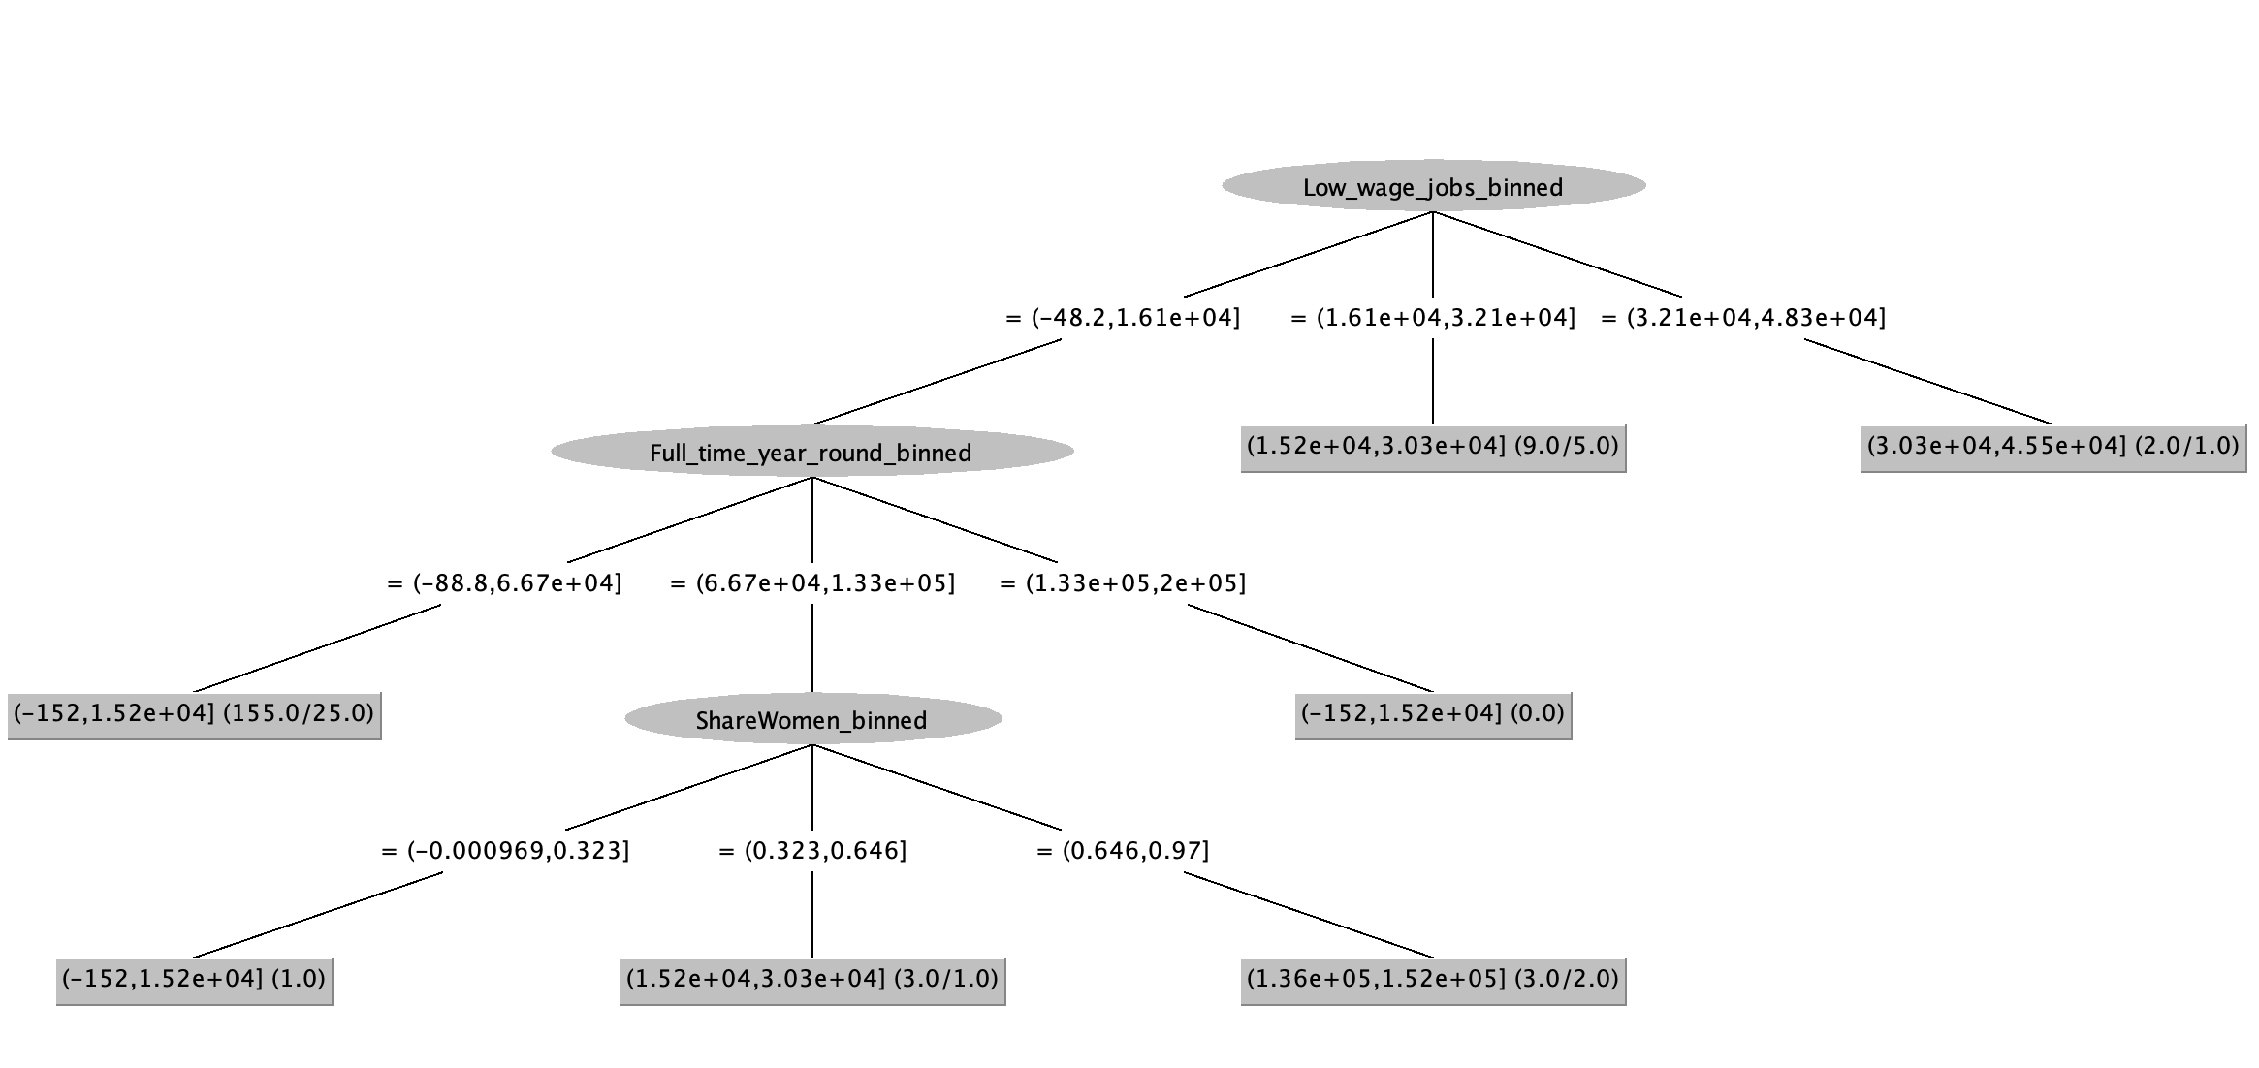
Apriori
For this algorithm I used recsub_binned4 with only my binned attributes and Major_category. This result did not use training and test splits.
Apriori
=======

Minimum support: 0.75 (129 instances)
Minimum metric <confidence>: 0.9
Number of cycles performed: 5

Generated sets of large itemsets:

Size of set of large itemsets L(1): 7

Size of set of large itemsets L(2): 5

Size of set of large itemsets L(3): 1

Best rules found:

1. Full_time_year_round_binned=(-88.8,2.01e+04] 131 ==> Sample_size_binned=(-2.21,423] 131 <conf:(1)> lift:(1.25) lev:(0.15) [25] conv:(25.9)
2. Sample_size_binned=(-2.21,423] Low_wage_jobs_binned=(-48.2,4.82e+03] 131 ==> Non_college_jobs_binned=(-148,1.48e+04] 131 <conf:(1)> lift:(1.26) lev:(0.15) [26] conv:(26.66)
3. Low_wage_jobs_binned=(-48.2,4.82e+03] 137 ==> Non_college_jobs_binned=(-148,1.48e+04] 136 <conf:(0.99)> lift:(1.25) lev:(0.16) [26] conv:(13.94)
4. Non_college_jobs_binned=(-148,1.48e+04] 137 ==> Low_wage_jobs_binned=(-48.2,4.82e+03] 136 <conf:(0.99)> lift:(1.25) lev:(0.16) [26] conv:(13.94)
5. Non_college_jobs_binned=(-148,1.48e+04] Sample_size_binned=(-2.21,423] 132 ==> Low_wage_jobs_binned=(-48.2,4.82e+03] 131 <conf:(0.99)> lift:(1.25) lev:(0.15) [25] conv:(13.43)
6. Total_binned=(-270,3.95e+04] 130 ==> Sample_size_binned=(-2.21,423] 129 <conf:(0.99)> lift:(1.24) lev:(0.14) [24] conv:(12.85)
7. Non_college_jobs_binned=(-148,1.48e+04] 137 ==> Sample_size_binned=(-2.21,423] 132 <conf:(0.96)> lift:(1.2) lev:(0.13) [22] conv:(4.51)
8. Non_college_jobs_binned=(-148,1.48e+04] Low_wage_jobs_binned=(-48.2,4.82e+03] 136 ==> Sample_size_binned=(-2.21,423] 131 <conf:(0.96)> lift:(1.2) lev:(0.13) [21] conv:(4.48)
9. Sample_size_binned=(-2.21,423] 138 ==> Non_college_jobs_binned=(-148,1.48e+04] 132 <conf:(0.96)> lift:(1.2) lev:(0.13) [22] conv:(4.01)
10. Low_wage_jobs_binned=(-48.2,4.82e+03] 137 ==> Sample_size_binned=(-2.21,423] 131 <conf:(0.96)> lift:(1.19) lev:(0.12) [21] conv:(3.87)

One similarity I noticed between a lot of the results of the different algorithms is that Full_time_year_round or it’s binned equivalent, Full_time_year_round_binned, often gets identified as an important attribute. In the J48 tree and the AdaBoostM1 tree I showed, Full_time_year_round and Full_time_year_round_binned are chosen for splits early on, and Full_time_year_round and Full_time_year_round_binned are part of the first rules in the rulesets generated by JRIP and Apriori respectively.

